St10469592
Section A
Student

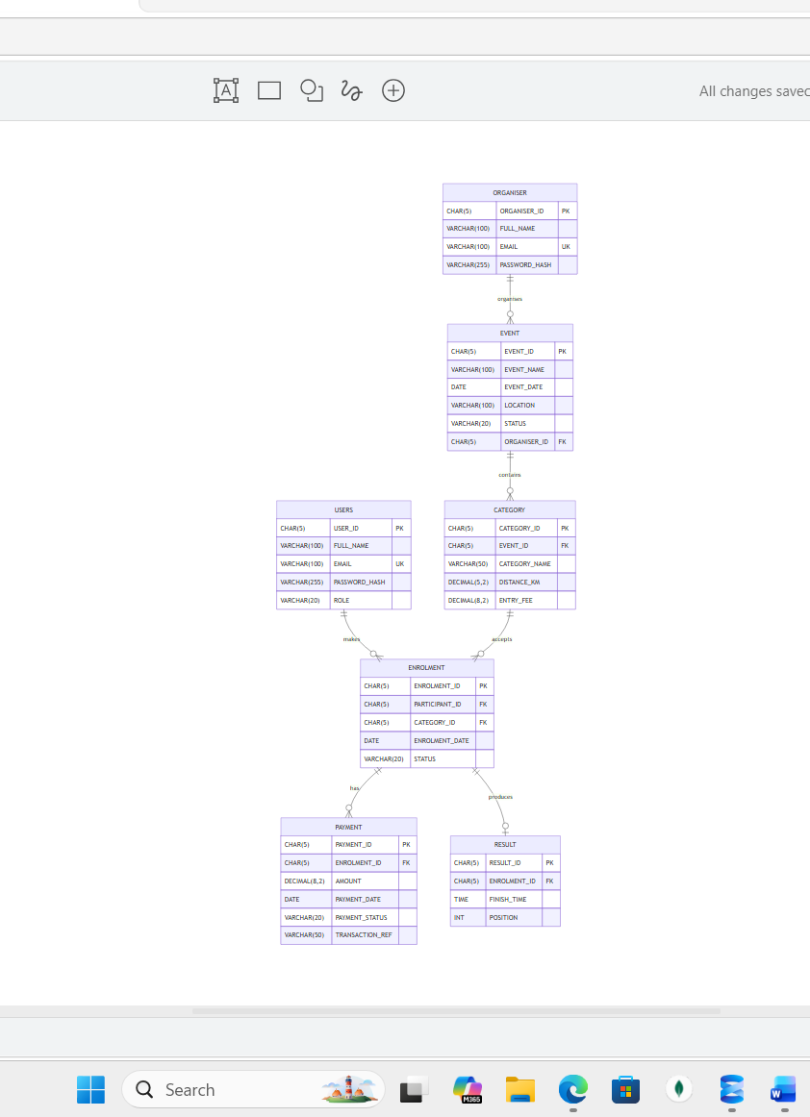
REFERENCES
Draw.io (2026) draw.io: free online diagram software. Available at: https://app.diagrams.net/
W3Schools (2026) SQL Tutorial. Available at: https://www.w3schools.com/sql/

